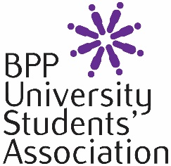
Guest Speaker Request Form
Please read the Freedom of Speech and Expression Policy and our Guest Speaker Policy before you fill out this form. This form must be filled in on all occasions that you intend to use a guest speaker who will be either on or off our premises. This form must be completed and emailed at least 15 working days prior to your event date or it may have to be postponed or cancelled.

Society/Club Details
Name of Society/Club:
Name of organiser and contact details:
Student ID:

Event Details
Name of event:
Date:
Time and location:
Is this an open or ticketed event?
Discussion Topic:
Are you likely to attract any media attention or have invited any news groups?

Guest Speaker Information:
Name:
Affiliation or Organisation:
Contact email:
Contact number:
Is this speaker seen as controversial in any way?

You must not advertise your event or confirm attendance with your speaker until this form has been emailed to engage@bpp.com and authorisation has been received by return email. The information provided in this form will be processed in accordance with BPP’s Privacy Policy (a copy of which is available at www.bpp.com/privacy).

