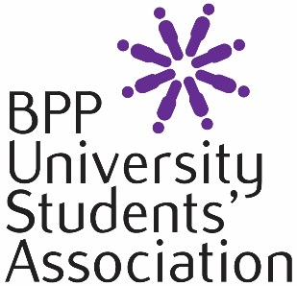 | BPP UNIVERSITY STUDENTS’ ASSOCIATION  BUDGET APPLICATION  2016-2017

You must answer all relevant questions providing the necessary details as required.
If you require assistance in completing this form, please contact Student Engagement team at engage@bpp.com
Data Protection
Please note that the information provided in this form will be used to asses and process your application. The information will be processed in accordance with BPP’s Privacy Policy (a copy of which is available at www.bpp.com/privacy). By submitting this form, you agree to your information being processed in this way.
Personal Details

- Student ID number (SRN): ……………………………………………………………

- Full Name: ………………………………………………………………………………

- Telephone numbers (including mobile if applicable):

...............................................................................................................................

- E-mail Address:

...............................................................................................................................

- Which society are you running?

…………………………………………………………………………………………….

- Which programme are you studying?

...............................................................................................................................

- Start date of your current course (DD/MM/YYYY) …………………………………

8. If successful in your application, what award are you looking for?
(Please note the maximum award for societies is £500 with sports societies having a maximum of £1,500. IF your society charges a membership fee, the Students’ Association will match fund up to an extra £500)

.............................................................................................................

17. What would your proposed budget be spent on? (PLEASE ONLY INCLUDE YOUR INITIAL APPLICATION AMOUNT FROM US AND NOT THE MATCH FUNDED EXTRA)
Expenditure | How much - £
BUDGET STATEMENT
Please use the space to elaborate on any of the answers you have provided above for your budget request.
Please note that applications submitted without a budget statement will not be considered for a budget allocation but you will still be entitled run your society as normal and can also have membership 'fund match' if you charge for membership
Continue on a separate sheet if necessary. Please ensure that any additional sheets have your full name and student record number on them. (PLEASE LEAVE DETAILS HERE OF HOW YOUR INTEND TO RAISE EXTRA FUNDING AND WHAT ANY MATCH FUNDED BUDGET WILL BE USED FOR)

Signature of Applicant: ……………………………………….
Date: ……………………………
Please return the form to the Student Engagement team at engage@bpp.com.

