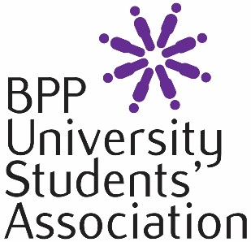 | BPP UNIVERSITY STUDENTS’ ASSOCIATION  BUDGET APPLICATION  2018-2019

You must answer all relevant questions providing the necessary details as required.
If you require assistance in completing this form, please contact Student Engagement team at engage@bpp.com
Confidentiality
Please note that all the information you provide will be treated in the strictest of confidence. Applications will only be seen by members of the Students’ Association team.
Personal Details

- Student ID number (SRN): ……………………………………………………………

- Full Name: ………………………………………………………………………………

- Telephone numbers (including mobile if applicable):

...............................................................................................................................

- E-mail Address:

...............................................................................................................................

- Which society are you running?

…………………………………………………………………………………………….

- Which programme are you studying?

...............................................................................................................................

- Start date of your current course (DD/MM/YYYY) …………………………………

8. If successful in your application, what award are you looking for?
(Please note the maximum award is £600 for all clubs and societies)

.............................................................................................................

17. What would your proposed budget be spent on?
Expenditure | How much - £
BUDGET STATEMENT
Please use the space to elaborate on any of the answers you have provided above for your budget request.
Please note that applications submitted without a budget statement will not be considered for a budget allocation but you will still be entitled run your society
Continue on a separate sheet if necessary. Please ensure that any additional sheets have your full name and student record number on them. (PLEASE LEAVE DETAILS HERE OF HOW YOUR INTEND TO RAISE EXTRA FUNDING AND WHAT ANY MATCH FUNDED BUDGET WILL BE USED FOR) and any other necessary information

Signature of Applicant:
Date:

Please return the form to the Student Engagement team at engage@bpp.com.

