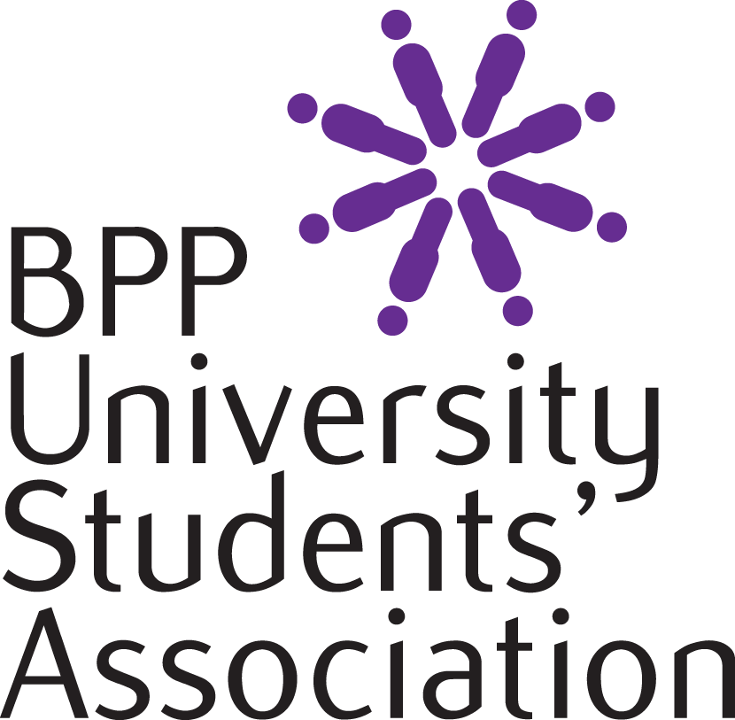

Student Written Submission
September 2017 – November 2018
Produced on behalf of all students at BPP University.
Written by Ahmed Dar, President of the Students’ Association with the excellent support of 24 Student Voice Representatives

INTRODUCTION
This is the seventh Annual Student Written Submission produced by BPP University Students’ Association. It provides an excellent opportunity for the National Student Council comprising of the Students’ Association President and 24 Student Voice Representatives to present the feedback given by the students over the last 14 months at BPP University. The use of an annual Student Written Submission has been recognised as Good Practice allowing the University to continually listen to the Student Voice, acknowledge key positives and make improvements collaboratively where required. It is with great pride that we are able to submit this document annually to BPP’s Academic Council and in particular this year to the Quality Assurance Agency (QAA).
I wish to thank BPP University for providing the Students’ Association with funding to host an annual away day where students can write this document, and we as a student body wish to thank the Independent Board of Governors of the Students’ Association for their support and direction in allowing us to produce this document and to remain independent, effective and focused whilst representing the Student Voice. Embracing the annual Student Written Submission proves that BPP University places student feedback as its highest priority.
The entire student body read the 2017 QAA report with pride, in particular this paragraph which is the pride of the Higher Education sector amongst Students’ Unions and Universities, “Students are satisfied that they have sufficient opportunity to provide feedback to the University and engage with quality assurance processes. Staff highlighted the outcomes from implementing inclusion representatives within the University. The team found the initial outcomes from creating inclusion representatives to be successful and to the benefit of the student body. Since the last QAA review visit in 2012, the University has provided the opportunity to the student body to create an annual student written submission. The University pays for the National Student Council to work together on the document over a number of days. The way in which this is facilitated and how the University responds to each of the recommendations is very beneficial and demonstrates that the issues are listened to and acted upon when appropriate, which is followed up through an action plan. Therefore, the team concludes that the opportunity for student representatives to create an annual student written submission that feeds into the University's strategic planning processes is a feature of good practice”.
I have recently been appointed the position of President (due to personal commitments I was only able to start the role in September 2018) after completing my undergraduate degree at BPP University. Prior to this role, I was an elected student representative on BPP’s Education and Training Committee and was fully immersed in Students’ Association activities including my roles within Enactus which is a global non-profit and community of student, academic and business leaders committed to using the power of entrepreneurial action to transform lives.
I hope I can make a difference in helping students throughout their student journey. This is one of the reasons that the format of this document follows the steps of the student journey before, throughout and beyond students’ time at BPP University. Although we could have used various different ways of presenting this document – i.e. by analysing departments one at a time, or by following the sections of the Quality Code, students felt that following the student journey works well for this Student Written Submission. My Student Voice representatives and I have also worked hard to identify areas of Good Practice, Recommendations and Affirmations and these are clearly marked within the document.
I believe that this document not only covers the quality and standards of the University but it covers many other topics which I believe to be a very important part of the student journey and hence although not all issues relate to academic departments, it is right that they are included in this document as they are integral to the Student Experience.
Each year these submissions take a significant amount of time and resources to produce. Some Students’ Unions with dozens of staff struggle to produce a document of this quality every six years, however the BPP Students’ Association team works tirelessly with our excellent student representatives to go above and beyond what is expected to serve the 16,000 students across nine different centres. This document is a reflection on the excellence of our students and the Association and the University should rightly be proud of this.
I have had some great experiences of working with students across every centre at BPP University. It goes without saying that I would like to say thank you to each and every student that has contributed to this report. This includes my 24 Student Voice Representatives but also the thousands of students who provided feedback in the Student Experience Survey or to their Staff Student Liaison Committee (SSLC) reps. The feedback that we have received helps us immensely to recognise good practice and to improve the student experience at BPP University. I would also personally like to thank our new Student Voice Manager, Hajra Babariya – Hajra was appointed by me as a result of the University agreeing to the recommendation for this new post in the previous Student Written Submission. Hajra is a full time employee of the Students’ Association and has helped collate data and documents used in this document and helped student reps triangulate and articulate key ideas. Hajra was also integral in organising the Student Voice representative training session and the student away day.
I would like to give special thanks to the Vice-Chancellor of the University, Professor Tim Stewart, the Deputy Vice-Chancellor, Professor Sally-Ann Burnett and the Head of Registry Operations, Laila Barbe for making themselves available to our student representatives and for their support in openly embracing the student voice.
I look forward to continuing to work with BPP University and all our students to ensure that the voice of every student is heard.
Ahmed Dar
President of BPP University Students’ Association

CONTENTS
Chapter Three – Independent Representation
3.1 Students’ Association Representation
3.2 Cohort Representation – SSLC
3.3 Individual Student Feedback – Student Experience Survey

Chapter Two - Training
2.1 Student Voice Representative Training
2.2 Student Voice Away Day
2.3 Producing the Student Written Submission
Chapter One - Methodology
1.1 Review of Previous Annual Student Written Submission and action plan
1.2 Feedback Sources
1.3 “You Said, We Did

 | Chapters Four and Five – Student Journey
4.1 Registration | 4.7 Library quality | 5.3 MoPPs and GARs
4.2 ID Cards | 4.8 Technology and recording events | 5.6 Exams and Exam Venues
4.3 Timetables | 4.9 CareerHub | 5.7 Mock Exams
4.4 Buddies/mentors | 5.1 Virtual Learning Environment | 5.8 Student Advice and Guidance Team
4.5 Lecturers and Tutors | 5.2 Technology in meetings | 5.9 Graduation and Alumni
4.6 Student Common Areas

Chapter 6 - Additional Feedback including Published Information

6. 1 Feedback on BPP website and social media
6.2 Going Green
6.3 University Signage
6.4 Staff signatures and out-of-offices

Chapter 7 – Thematic Element Mental Health
7.1 Mental Health
7.2 Mental Health First Aid Awareness Course

Chapter 8 – Learning Opportunities
8.1 Feedback Turnaround times
8.2 Student Led Staff Excellence Awards

Chapter One - Methodology

Review of the previous Annual Student Written Submission and action plan
The National Students Council is made of 25 members – these are the 24 Student Voice Representatives representing a range of programmes and centres and Ahmed Dar, a recent BPP University graduate and full-time President of BPP University Students’ Association.
The National Student Council spent a large amount of time reading through the previous Student Written Submission and the response document and action plan that BPP’s Head of Student Experience, Shahban Aziz kindly presented. This comprehensive document shows that most actions have been successfully completed – for example the appointment of a Student Voice Manager – and that all others are on track. The National Student Council is pleased to sign off last year’s Student Written Submission and action plan and thanks all staff at BPP University for the prompt response in completing all actions. Where certain items are on-track, these are clearly mentioned within this document as affirmations.
Unlike the previous Student Written Submission which marked aims separately to recommendations, we have decided to use the following three areas to highlight key positives, recognitions and recommendations.
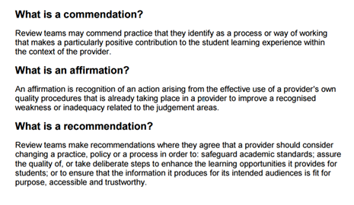
Source www.qaa.ac.uk

1.2 Feedback Sources
The President and Student Voice representatives created this Student Written Submission having reviewed a wide range of sources of information from across the University. The following documents were reviewed by the Student Representatives.
- Previous Student Written Submission 2016 -17;
- Minutes of the Student Staff Liaison Committees;
- March 2018 Student Experience Survey;
- July 2018 National Student Survey Results;
- Students’ own experiences and triangulated formal and informal feedback from fellow students; and
- Feedback from Focus Groups.

1.3 “You Said, We Did”
The most important part of any feedback mechanism is completing the feedback loop and BPP University are leaders in ensuring that this happens. Student Voice representatives who study post-graduate courses at BPP and who have studied elsewhere commented that their previous Universities were not as effective in taking on board feedback and responding to students with details of actions taken.
Affirmation: Student Representatives are pleased to see numerous “You Said, We Did” and “Did You Know” posters across the university and request that new posters are put up regularly in-centre and on the VLE to enable all students to understand that feedback is being taken on board.

Chapter Two - Training

2.1 Student Voice Representative Training
Good Practice A comprehensive Student Written Submission has been produced each year by the BPP Students’ Association since the QAA review in 2012.
Each year there is funding available by the Students’ Association to allow the Student Representatives to attend an external venue to address feedback that is provided by the students. During this event the Student Representatives also make recommendations for any improvements to the University.
Student Voice Representatives also appreciate the opportunity of an away day which allows them to network and meet as a group of senior representatives from across different BPP University centres. Additionally, the Students’ Association uses this away day to provide further training to student representatives.
On the recommendation of last year’s Student Written Submission, a new role of a Student Voice Manager has been created and successfully filled, with the President of the Students’ Association chairing the recruitment panel for this role. This role is instrumental in further strengthening the Student Voice, in providing training to student representatives and in allowing the Staff Student Liaison Committee (SSLC) system to go from strength to strength.
The Student Voice is valued at BPP University and is given the highest priority by BPP University tutors and professional support staff. For the Student Representatives to fill their positions successfully, a comprehensive paid training day was held for the Representatives – where student representatives were paid for their time of attending the training session. The overall aim of the day was for the students to understand the importance of their role, to gain an overview of BPP’s committee structure and to develop skills in how to triangulate and present feedback from students – and then how to present this back to students.
During this day, there were also brief presentations and opportunities to meet the following senior staff members in addition to the Students’ Association team:

Professor Tim Stewart – Vice-Chancellor

Professor Sally-Ann Burnett – Deputy Vice-Chancellor

Mark Griffiths – Director of Operations
- Nicholas Glossop – Head of Inclusion and Learning Support
- Christina Lambi – Inclusion Officer
- Michael Martin - Library Manager
- David Donnarumma – Head of English Language and Testing
- Shahban Aziz – Head of Student Experience

David Tomas-Merrills – National Head of Careers
There was also a Networking Lunch where many more staff members attended. All Student Representatives appreciated the fact that senior members of BPP University took the time to meet them and provide overviews of their areas and this demonstrated the value that BPP University places on their roles. In particular, students appreciated how Mark Griffiths gave contact details for his senior team and stated that any student can contact him or his team at any time – and this showed an open and all-embracing approach by BPP to students. Student Voice representatives also enjoyed sessions on the NSS, QAA, TEF, SWS, DFE, OFS and other exciting three letter acronyms which opened the mind to areas that were previously unknown.
Amongst our Student Voice Representatives there are a range of students from programmes and centres across the University, so we can be confident that we are representing all students. This year the Student Voice Representatives will also be provided with certificates presented by the Students’ Association in addition to all SSLC representatives being presented certificates – which is a successful action enacted as a result of feedback from the previous Student Written Submission.
These are this year’s Student Representatives – who all were invaluable in providing information for this SWS:
Name | Centre | Course
Wasim Khan | Distance Learning / Manchester | LLB (Hons)
Kamara Lee | Shepherds Bush | MSc Management w/ Finance
Emma Wilson | Holborn | LLM/Legal Practice Course
Hassan Daniyal | Shepherds Bush | MSc Management with Project Management
Kabir Abdulrazaq Abdulsalam | Shepherds Bush | MSc Management with Project Management
Farheen Rasheed | Shepherds Bush | MSc Accounting & Finance (ADAF)
Arsalan Ul Haque | Waterloo | LLB (Hons)
Nasrin Akter | London City | MSc Management with Project Management
Patience Hamoonga Hamalabi | Waterloo | Nursing
Rabab Eric Khokhar | Shepherds Bush | MSc Management w/ Finance
Suhel Uddin | London City | (BSc) Accounting & Finance
Stephen James Clarke | Shepherds Bush | ADAF/MSc Accounting and Finance
Fahad Ittikaparambil Palakkal Haneefa | Shepherds Bush | Advanced Diploma in Accounting and Finance
Nafisah Dowlut | London City | (BSc) Accounting & Finance
Tsz Lam Yip | Holborn | LLM/Legal Practice Course
Michael Abiodun Olatokun | Holborn | LLM/Bar Professional Training Course – Part-Time
Anna Visangirieva | London City | Banking & Finance
Priya Shah | Waterloo | LLM
Ghana Mustafa | Waterloo | LLB Hons
Ibrahim Al-Ojaili | Waterloo | LLM/LPC
Fatjeta Malaj | London City | Banking & Finance
Jonathan Warrilow | Shepherds Bush | iMBA
Kurt Satney | Waterloo | LLB
Denise Ester Makashi Tetela | Waterloo | Nursing
Andre Henrique Vasconcelos Ferreira | Shepherds Bush | iMBA
Ianthe Wallace (Beth) | Cambridge | LLM/Legal Practice Course
Yerzhan Baitubayev | Birmingham | Legal Practice Course
Sunnan Farukh | London City | (BSc) Accounting & Finance

The list above contains 28 reps, including 4 who were unable to attend the away day but did provide input and feedback in writing separately.
We are proud to note that our student representatives span across undergraduate and post-graduate courses, many have studied at other universities, some are international whilst others are UK domestic students, some are part-time or distance learning students, some are BME and we also have student representatives who are young, others are mature and some have children of their own – this diversity gives a rich insight into how the needs of different students are identified and met by BPP University.
Additionally, the President of the Students’ Association conducted focus groups to gather even more feedback, e.g. a focus group with Nursing students in Doncaster which was very successful with all Nursing stating they would recommend a friend or family member to study at BPP University.

2.2 Student Voice Away Day
This year the Student Away Day was held at Wembley Stadium, which allowed for an intense day of work in comfortable surroundings followed by an evening of fun including a private tour of the stadium. Whilst BPP University staff were allowed to visit for the tour and for networking/meeting with Student Voice Representatives, they were not allowed to be present during the closed sessions when feedback was being discussed and this document was being written.
Student representatives who had been in similar positions at other universities commented how they had never met a Dean or Vice-Chancellor at their previous universities, but at BPP the accessibility of the most senior staff is to be commended as this demonstrated that staff across BPP genuinely value
Students as Partners and more ‘Students as Leaders’.
Dinner the night before the Student Voice Away Day
One of the reasons why this entire document is in landscape is because the clarity of the text, images and screenshots used suit a landscape format, and another because the final version of this document once design and binding has been completed will lend itself to this landscape format.

2.3 Producing the Student Written Submission
Producing this document requires a lot of time and planning. Fortunately, Ahmed Dar, the Student President, was able to plan the Student Training Day and Away Day in time to incorporate the feedback from these days, supplemented by feedback from numerous focus groups with students who were not student representatives and also with those who were student representatives.
It is a testament to the hard work of the entire Students’ Association team that we have been able to produce such a robust and extensive document, triangulated and mapped to the Quality Code and the Association are to be commended for this.

Chapter Three – Independent Representation

3.1 Students’ Association Representation
The Student Association at BPP University was formed in 2011 and one of the main purposes of the Association is student representation. The association is representative of the entire student body at BPP University.
The Student Association consists of the following staff members:
- Ahmed Dar – President
- Alison Parker – Education and Welfare Service Manager
- Iain Kinnear – Education and Welfare Service Manager
- Azmat Suleman – Student Engagement Manager
- Hajra Babariya – Student Voice Manager

This document has been produced with help from all the above and the Student President gives great thanks to all of them.
Students commend the excellent work of Alison Parker and Iain Kinnear in providing excellent, tailored and independent advice and in assisting them courteously, confidentially and with prompt turnaround times. However, as this document is not a review of the Students’ Association, we will not go into too much detail except to formally recognise the contribution of Alison and Iain and to recognise that the service they provide is invaluable to students. This has already been passed back to senior management by Student Voice Representatives outside of this document.
As well as student voice activities, the Students’ Association focuses on independent advice, student representation, assisting students in hardship and in the field of student engagement. Students continue to commend the range of academic, social, political, religious and cultural clubs and societies across BPP – with 62 clubs and societies that are thriving across BPP centres. Popular Students’ Association clubs and societies include the Advocacy and Debating Society, the Commercial Awareness Society, Enactus, 5-a-side Football, Netball, Yoga Society and the Chess Club.

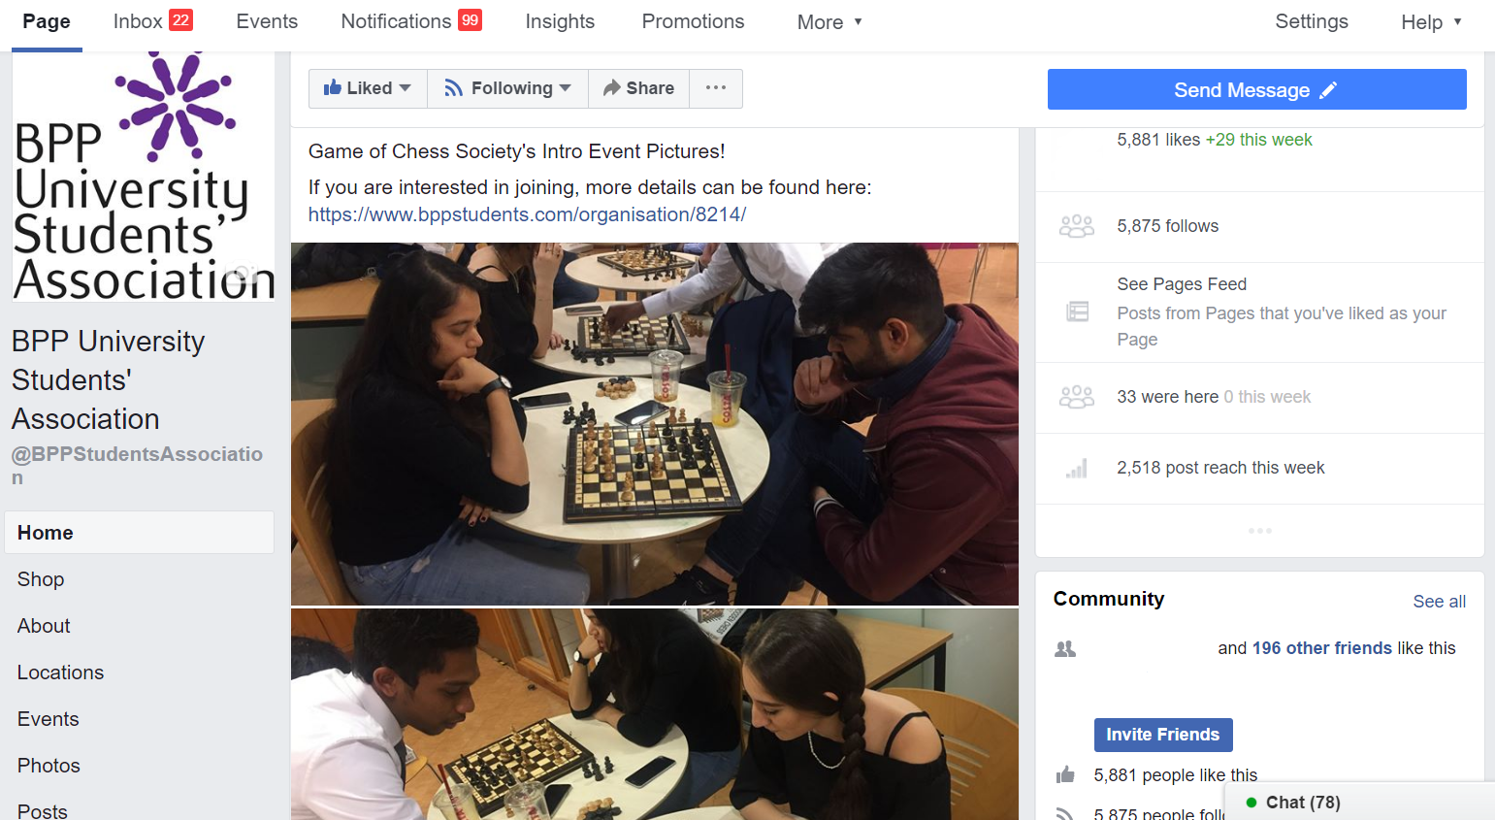
Student representatives were also interested to learn that two former Presidents of the Students’ Association now work at BPP University in senior key Student Experience roles – and this once again shows the value that the University places in championing those who are advocates for the student voice. Employing Alumni and Presidents in this way allows the University to understand the rationale for student feedback. Additionally, as many BPP University staff also undertake BPP programmes, they are also able to experience first-hand the excellent teaching and opportunities available – and make improvements if and where required quickly and effectively.

3.2 Cohort Representation
Staff Student Liaison Committee (SSLC) representation forms the foundation of the collective student representation system at BPP University. Elected SSLC representatives directly represent their tutor group or cohort at meetings with members of their programme leadership team. The SSLC minutes feed directly into the documents of the University School boards and Students Voice representatives see these on SharePoint, at Board Meetings and as part of this Annual Student Written Submissions.
SSLC reps are elected by popular majority of their class peers if two or more candidates stand and there are 300+ SSLC reps in total across all centres of the University. SSLC reps from Autumn 2018 onwards are given a comprehensive training video to watch and will now receive a certificate to recognise and reward their service once they complete their term in Spring 2019. SSLC reps are excited to receive the certificate at the end of their service, and this increases the profile of SSLCs.
Affirmation The Staff Student Liaison Committees are being better promoted across the university and should continue to be further promoted.
Students also sit on Boards and Committees at BPP University and are paid for each meeting that they attend as well as given vouchers for attending focus groups.

3.3 Individual Student Representation – Student Experience Survey
In last year’s Student Written Submission there was a concern raised regarding individual feedback and no central location for this feedback to be collated and results examined. This issue was raised by the President of the Students’ Association, who was given an action by the Academic Council to look into how students are being surveyed and how it could be improved.
Following the formation of a Student Survey Working Group, chaired by the President of the Students’ Association and attended by Head of Student Experience, Shahban Aziz and members of the Education Services team, the University decided to use EvaSys for all student surveys going forward. This will create a single location where all results are located and allow for control over the number of surveys sent to students.
The Student Experience Survey is one of a range of surveys sent out via EvaSys and this surveys students around 6-8 weeks after they start at BPP University. This survey allows students to provide individual anonymous feedback across various areas of BPP and student representatives read hundreds of anonymous comments from this survey – the vast majority of which were overwhelmingly positive. Negative comments or comments suggesting areas of improvement were triangulated with SSLC minutes and included as recommendations within the document.
Good Practice The use of the Student Experience Survey to gauge feedback at the start of the student journey as a barometer of the student experience – and in order to make improvements quickly – is a feature of Good Practice at BPP University. Students have seen You Said We Did posters as a result of feedback resulting from this survey and appreciate that feedback is taken on board and improvements made.
Students have noted that they also complete End of Module Surveys, however they don’t always get told what has happened as a result of this feedback. Recommendation: Students would appreciate an email update on the actions taken as a result of end of module feedback. Whilst they may no longer be on that module, it is important to know if changes have been implemented – as improvements will inevitably help future students as well as current students on other modules.
There was an extensive discussion around whether the feedback would identify particular tutors and hence kept anonymous, however Student Representatives were happy for it to remain anonymous as long as the feedback loop is completed. Recommendation: Student Voice Representatives would like to see an anonymous aggregate summary of end of module feedback, key positives and negatives, themes and actions taken – ideally in report form once per term and at the relevant boards and committees so that this can be analysed and discussed.

Chapter Four – Student Journey

4.1 Pre-Arrival Information
Students were pleased to find that BPP emails were set up before registration, providing an efficient communication channel for students regarding dates to attend to register, collect ID cards, timetable updates, library facilities, including preliminary reading etc.

Recommendation: Most Student Voice Representatives commented that they received a number of emails prior to starting with BPP, and that they would prefer a hard copy welcome document prior to starting at BPP. This could include a handy checklist, or a welcome letter from the Students’ Association, or a welcome from the Vice-Chancellor, or a student magazine or a goody bag, or branded items, or even a postcard advising students that they are joining a community and this would help them feel welcomed rather than receiving mail-merged emails. Discussions were held as to this not being eco-friendly, however one letter or package compared to the entire one or more years of study meant that overall this was an essential document. Students currently receive £25 of free printer credit when starting at BPP, and would rather receive £24 and a magazine in the post, than have no physical documents from BPP prior to starting.

Affirmation: During registration there were stalls set up by the different teams at the University, such as the Students’ Association, Alumni Team and the Student Advice and Guidance Team. This was seen to be very useful as it gave the students information on where they could go for different types of help – and students wish to see more of these stalls as they feel it is helpful for their fellow students.
For all new students there are induction sessions held for the students providing students with information about their programme and other opportunities. Induction on the whole is excellent, however sometimes there is information overload and instead students would prefer less information at induction with a focus instead on the important information that they must remember.
Some important information that the students would require would be:

- How to access the Virtual Learning Environment (VLE);
- Details of any support services, personal tutor etc.
- Which team to go to if they need a specific problem resolving, i.e. Student Records, Student Advice and Guidance etc; and
- How to access timetables.

If just these messages were passed successfully to the students at induction a lot of the student issues could be resolved much more efficiently.

Students were offered the opportunity to speak to a tutor or a student prior to starting at BPP – in order to ask them questions and to get a feel of University study. Students who took up the opportunity felt that speaking to a current student was invaluable in allaying their fears and helping them decide on whether BPP was right for them.

Good Practice: Students are given a hard copy induction guide at registration and via email prior to arriving and this is universally loved by students. It is especially pleasing to note that it has been created in partnership with students and the Students’ Association – and students want to formally note their appreciation at how this document is their ‘student bible’ to life at BPP.

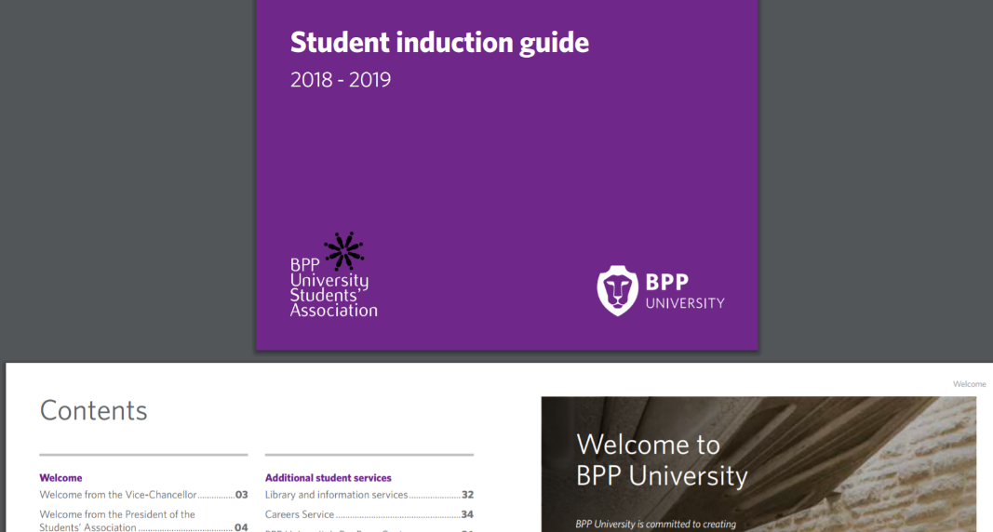

4.2 ID Cards
There was a delay for some students receiving their ID cards as there was a delay in the printing. This was not a particularly huge issue for the students, but as correctly raised this could cause some potential security issues – and also meant they were delayed in getting discounts from local and national retailers.
Recommendation: The best solution to this would be for the students to receive the ID cards at the point of registration, however if this is not possible then a temporary card should be issued. Some students also commented on the quality of the card as the ink rubs off easily and whether a laminated or higher quality card could be issued – as after 1-3 years of wear and tear the card is sometimes unrecognisable. Students would also appreciate having a QR code on the back or a handy list of numbers to call or even a quote or a welcome message.

4.3 Timetables
Timetabling is a very important topic to all students. In the last year timetables have improved and the students now get their timetables earlier. A number of considerations need to be taken into account when the university consider individual timetables, such as students who work part-time to support themselves through full-time studies and some students have family or other personal commitments.
Some programmes offer timetable options at the beginning of the course allowing the students to fit their studies around other commitments, however, other courses do not offer this and this is an issue to some students.
Here are some comments from the students:
“Last minute or late timetables occur more frequently than is acceptable. The university should aim to provide students with the next term’s timetable a month before lessons begin to allow time to arrange work or family commitments around it. No student should miss their classes because their timetable has not been updated, if an IT issue prevents this the university should contact affected student and inform them of lecture dates.”
“A few students have complained about timetable conflicts which the university was not able to resolve to their satisfaction with one student being told to miss one of their lessons when a clash occurred.”
“Students would also appreciate lessons to be timetabled on the same days each week to help them arrange work commitments around it.”
There have been significant developments by the University on other areas relating to timetables. This is the feedback received from the University:
Office 365 Timetables
The first project which we hope to launch next year is to get all students (and staff) receiving their teaching timetables directly in to their Office 365 calendars. This will allow students to receive notifications of any short notice changes made to their timetables in ‘real-time’. It will also mean that they can effectively sync any commitments outside of the teaching they need to attend with their timetabled classes.
Student Allocator
The second project would be Student Allocator, which we are also hoping to launch in 2019. This system essentially allows students the flexibility to design their own timetable through the options in their programme allowing them to ensure the best balance between work and non-work commitments. At the beginning of each term/academic year students will access Student Allocator and select the teaching groups they wish to attend for the modules they are studying. They will be presented with a grid timetable at the time of choosing to let them see which groups are running on which days/times meaning they can choose a timetable to suit them.
Affirmation: Students are aware of and support these two projects and wish to see it implemented in a timely fashion.
Recommendation: Students also request that if a class needs to be changed at short notice for any reason that customer service teams are made aware of this, that a notice is put on the VLE and is sent via email and that they receive a text message if possible. A handful of students who travel 1-2+ hours to a cancelled class find that the cost and experience is enough to sour their whole experience of university. Whilst this may happen on some programmes, it should happen for all students.

4.4 Buddies/mentors
The School of Business and Technology currently have mentors that are available to students and these have been welcomed by students. If this is a successful pilot, it would be great to see whether this is expanded, however students appreciate that the pilot is currently ongoing and wanted to thank the University for this opportunity.

4.5 Lecturers and Tutors
The feedback from students regarding the quality of teaching at BPP University is remarkable. According to students:
“…the teaching cannot be faulted. Lectures are excellent to attend, and the tutors are very helpful and understanding.”
“The students have expressed almost universal praise for the exemplary teaching provided at BPP University. Tutors on the whole are regarded as attentive, knowledgeable and kind with many willing to forgo their lunch hours to help provide extra support to students. In my opinion the teaching staff are the greatest resource BPP has.”
“Tutors continue to be professional and display high levels of integrity and are a great source of inspiration and practical advice on life in practice.”
Good Practice: The quality of teaching is excellent with sector-leading engaging tutors:
- Tutors are attentive, and frequently current or ex-practitioners so seem like they have a good handle on their knowledge;
- Lecture materials are well put together;
- Study notes are comprehensive and easy to read; and
- Lectures are clear.

4.6 Student Common Areas
There have been significant improvements in the student common areas and facilities across various centres. The consensus of the students is positive, however, for any more challenging comments the students have provided some ideas to overcome this challenge:
- (Waterloo Specific) There is a lack of first-aid rooms for such a big building to handle any emergency situations that may occur.
- “Students are generally pleased with the cafeteria space provided and make frequent use of the microwaves and TV. There is a desire however for some amenities to be provided free of charge, such as hot water, which students must currently pay for. The provision of a kettle or hot water tap would be welcomed.” Students appreciate that the charge may be for the cup and not for the water, but find it absurd that this is being charged for. It is often the smallest items like paying for a cup that diverts the most attention away from positive or negative comments about high-level matters.
- “A number of students have expressed appreciation at how clean and tidy the campus is kept. The friendly cleaning staff can always be seen working diligently to keep the campus and grounds spotless.”
- “Students are also delighted with the recent inclusion of benches and a table tennis table on the grounds and would like the university to continue provide more fun leisure facilities like these.”
- “Students in City campus generally like the campus area and the decoration of the campus. The student lounge seems to be very helpful for the small campus. The coffee vendor machine was a fantastic facility for the students with cheaper option. Students appreciate the free decaf coffee. A student’s belongings in the campus would be more appreciated. There were some lockers already installed in the corridor along with the new refurbishment work in Fitzwilliam house. If they are open to students then, it would be great.”
- “Buildings are kept neat and clean and it is perfect fit for the purpose. Toilets are maintained properly. There are some great improvements in the Shepherd’s Bush centre. They have introduced table tennis, some wooden tables and seats which students can socialize outside the building.”
- “Religious students appreciate the prayer room and make a good use of that.”

The multi-faith rooms are extremely useful for students; however, the students ask the multi-faith room at Waterloo to be maintained and cleaned with a new carpet being provided. As one of the most used rooms at BPP, a refurbishment of the room is requested and students feel this will make the space even more welcoming and a place for meditation and for quiet contemplation.
Affirmation: Student Voice Representatives are pleased to hear about the Student Spaces Review as described in the action plan to the previous Student Written Submission and ask that this be completed in a timely manner, with the Happy Café provision being evaluated within this Review.
Students also compliment the friendly Customer Service Advisor team who are at the reception of each of BPP’s centres.
Students are also pleased to note that improvements have been made following meetings with staff members. After one Student Voice Representative gathered feedback about their centre, they immediately saw a number of positive actions including additional microwaves, new water machines (hot and cold), some board games and large Connect 4 game for the common room and healthier snacks in the vending machines. This shows that the Student Voice is at the heart of BPP and both academic and non-academic feedback is immediately acted upon.

4.7 Library quality
The library team continue to receive excellent feedback from students. Students who have been here for a number of years have commented on the significant improvements that have been made across the various libraries. The library staff also continue to receive high praise from all students. It was agreed that each and every library has all the necessary resources for the students and that there is great access to both digital and physical materials.
There were some concerns raised about the size of the library at Shepherds Bush, however, students have been advised by the University that this is currently under review and will look to be resolved. Unfortunately, it is a difficult site to work with but the University will look to find a solution and students have reported positive progress in this regard.
A small but quite vocal minority of students have asked that the library hours at the Shepherds Bush campus be extended past 8pm and possibly to 24 hours. However, a 24-hour library has been trialled and the library was not being sufficiently utilised and therefore students understand that the library will not be staying open for 24 hours.
Recommendation: Students have requested that at least one London library be made available to them later in the evenings during the weekends for study – or for a review of whether another trial would be beneficial around exam time.

4.8 Technology
Students noted that the University has a strong focus on embedding Digital Skills to students and the Digital Skills conference was well received by students. They want to see more conferences where they can learn from sector leaders and better equip their CV’s.
Some students wanted to thank the University for providing free access to the Financial Times online, whilst others were unaware of this. An email to all students with a poster of what they can access for free would be appreciated by students – and this poster could also be displayed in each Library as some students don’t look through the Online Library for this information and would like to one document with all the packages available to them.
Students also noted that there is a new process to improve how BPP receives applications for Mitigating Circumstances and Academic Appeals Previously, these were submitted via paper form and it was found that this process was inconvenient for the student and laborious for all involved.

Affirmation: The outcome of this project has been to design and develop two new online application forms for University students to be able to submit their application for either Mitigating Circumstances or Academic Appeals. Students appreciate this improvement and will continue to provide feedback on the process.

Recommendation: Students are highly appreciative of the range and quality of materials on the VLE, but would also like to be able to download lectures in .mp3 format – and if this is already possible then students would like an information document explaining how this could be done.

4.9 CareerHub
Students love CareerHub as an online resource for students – and one that helps them with employability and Career Ready skills. Students get a CareerHub account automatically when joining BPP and so it is all set up for them – and they find it a useful tool.
The National Head of Careers informed Student Voice representatives that any prospective students can use the careers service once they have signed up and they can also use CareerHub up to 2 years after they have graduated – something which is to be commended.
Good Practice: Students are aware that there are able to become Careers Ambassadors and they note that the number of Ambassadors is increasing – as these ambassadors help spread the word about Career and Employability services across the university. Many of the Student Voice Representatives are also Careers Ambassadors and the synergy of these two roles works very well. Students feel more teams should have roles for students to be paid ambassadors – the possibilities are endless - Marketing Ambassadors, Student Advice and Guidance Ambassadors, Centre Welcome Ambassadors, Graduation Ambassadors etc.
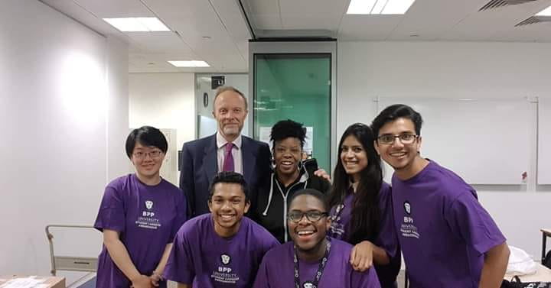
Students have expressed that Careers advice is excellent, also for distance learners, however, the distant learners feel that they themselves need to be more pro-active in contacting the career advice team initially.
Here are some of the comments that came from the students:
“Excellent service, no problem liaising with the team and opportunities are bountiful especially for law students.”
“Careers provides the assistance needed in ensuring that we receive opportunities and feedback on ways to improve our skills and the staff provide great customer care. They are to be given gold star awards”.
Students in Birmingham have asked for more workshops, whilst some students have asked for closer links with Chambers who may wish to provide mini-pupillages to BPP students. Although this may not be possible, an increasing number of students would like additional support in this difficult area and wanted to see if Careers could do even more in this area if possible.
Most students were aware of the Career Ready Strategy but some wished for more posters, signage and emails referring to it – as well as more information on the homepage of the VLE. Students felt this should be mentioned in every classroom as being ready for a Career is the ultimate aim of studying at BPP.

Chapter Five – Student Journey

5.1 Virtual Learning Environment (VLE)
The VLE is thought to be a great resource, particularly if it is utilised correctly. Students feel in order to be able to master the VLE there should perhaps be mandatory training at induction.
All students and especially ADAF and ACCA students have already seen some improvements to their VLE,
“Now we have a good picture of what we need to prepare, what we are going to engage in class and what should we do after class in order to pass the exam. They incorporated question debriefing videos and past year question papers, so we don’t need to depend on other websites.”
Although there are many positive points to be made about the VLE, there have also been some suggested improvements:
- Make the interface more user friendly;
- An announcement box on the home page of the VLE for important notifications;
- When accessing the VLE for the first time, a demo of how to use the VLE may help;
- If all the student details are updated on the VLE it could resolve issues such as receiving the relevant notifications. A campaign could be run asking the students to update their profiles on the VLE, so the most up to date information is attached to their profile; and
- Along with important announcements being shown on the VLE, automatic text messages could be used as a communication tool alongside an email notification.

Affirmation: In response to the student comments at the Student Voice Away Day, Laila Barbe, Head of Registry Operations responded to say that they are already in the process of making changes to the VLE to improve the user friendliness. There will be a specific focus group set up with the students to identify some of the specific issues. The students were very happy with the feedback given by the University.

5.2 Technology in meetings
Students noted that many meetings are online, however they don’t always know the staff members in the meeting, and so some meetings should be face to face so they can meet all attendees. Whilst BPP staff know each other, a Student Voice Representative who dials in for a meeting all year feels alienated never meeting many of the people they engage with. More thought needs to be given to some meetings, especially longer ones or alternate ones being face-to-face.
Recommendation: Students also noted that BPP was looking into having better facilities for conference calls, video technology and better cameras in rooms for Skype calls – and these could be used to stream events – however these have not materialised since the 2017 Student Written Submission.

5.3 MoPPs and GARs
Student Voice Representatives are aware of the Manual of Policies and Procedures (MoPPs) and the General Academic Regulations (GARs). Students know that these are available on the VLE and on the www.bppstudents.com website, however students do not actively need to be aware of all the detail except that they know they are there if they need them e.g. if they need information on a specific policy.

5.4 Exams and Exam Venues
As we continue to go through the student journey, students raised feedback on exams and exam venues.
Students were pleased to hear that the university is committed to moving towards computer-based exams and marking applications and that the pilot at the Law School has finished with the initial results looking promising. Student Voice Representatives wish to be involved with any trials and want to help in any way as required.
With regards to exam venues, some students stated that there should be desk allocations at all exams, as this did not happen at all venues, and the risk was that students may end up in the wrong hall – especially at a larger venue. We have not been able to assess whether this is an issue affecting a small number of students who may be stressed going into an exam and thus the potential for confusion is greater, or a larger issue
but Student Voice Representatives asked for this to be included in this submission.

5.5 Mock Exams
Overall the vast majority of students commend the range, quality and relevance of formative assignments – and on the whole feedback is given promptly on these assignments.

A small number of students commented on the timing when formative assignments are released:
“Formative assignments have only been released in Week 5. This seems somewhat late considering terms only last 10 weeks (including reading week). Comparing this to other universities that I have studied at, this is surprising. Upon starting a module, I would expect module leaders to introduce the topic and what is the expected outcome, followed by the assignment. I understand that these modules were put forward for review and acceptance before release, but why is this done after the terms starts, rather than before? “

Whilst there is never an ideal time to release formative assignments, and also with multiple modules students need to have a spread as having to complete a formative assignment in the same week for all modules is impossible, it may be prudent to explain the formative assignment release dates in class so students understand the rationale and can put all dates in context of one another to assist with planning for formative assignments.

5.6 Student Advice and Guidance Team
Students who have used the Student Advice and Guidance Team find them to be courteous, helpful and prompt in answering queries.

Students who have been here for a number of years have found the team to have improved with quicker turnaround times and generally a greater awareness of the services offered. Students also noted that the Student Induction Guide clearly and helpfully explained the services on offer from this team and other teams, and this meant that students used the service more for the right types of queries.
Students were also pleased to see the new case management system that has been implemented. This new online query form helps address queries quickly and efficiently and entirely online. Students can choose from a list of query types and submit an online query that will be automatically directed to the relevant team who will deal with your query.
The types of queries students can submit include;
- Change of contact details
- Debt management
- Examinations
- ID Cards
- Oyster Cards
- Interruption of Studies
- Letter production
- Locker Key
- Student status
- References
- Registration
- Timetable
- VLE content issues
- University Complaint

The system also recognises the student email address and pre-populates key fields, making it even easier to raise a query and receive a prompt reply. Student Voice Representatives thank the university for implementing this innovative system to make raising queries easier and more effective.

5.7 Graduation Communications and Alumni
Students love graduation. Student Voice Representatives who have been here for more programme (e.g. a current postgraduate who also studied their undergraduate qualification at BPP University) state that BPP graduation is amazing.

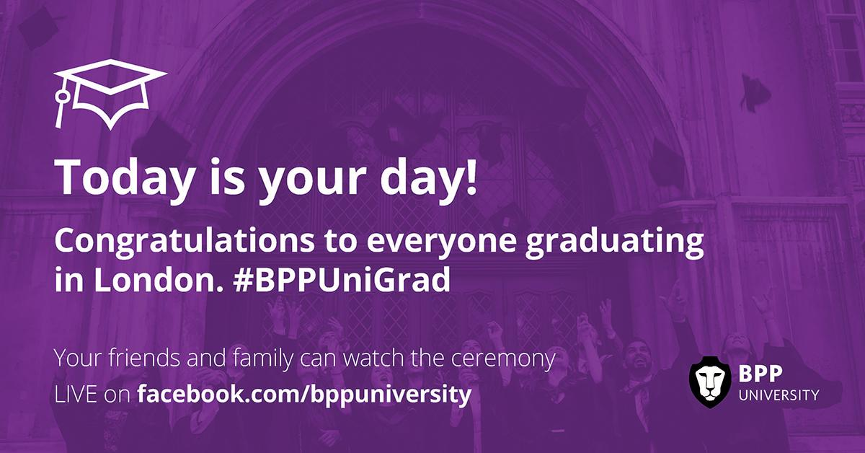
Students who attended Graduation at the London Guildhall stated that they have never experienced such a magical day and it was amongst the best day of their lives and that of their parents and guardians. Their only comment was that they wish to see more posters, videos and information about graduation throughout their time at BPP so that they can look forward to the day and know what to aim for. They want the website to publicise more information about graduation and even if they aren’t graduating to receive an email and a notice on the VLE that the ceremony is being livestreamed and where they can watch it – as they would want to see what a ceremony is like even prior to their own graduation.

Chapter 6 - Additional Feedback including Published Information
6. 1 Feedback on BPP website / Students’ Association Website and social media
In the students view the BPP University Website conveys the key messages that are required for prospective students. However, it seems that not many students have had the need to use the website once they have started the University as they instead use the Students’ Association website, or the VLE for key announcements.
The navigation seems to be quite easy across the BPP website and anything that the students have had to search for has been found. The website shows clearly the different schools that exist within the University, and what opportunities exist within those schools – alongside details of all programmes.
Recommendation: Students notice that the website doesn’t have many images of students and whether this could be improved. Students pointed out that the homepage has pictures of a number of people, presumably lecturers or managers, but none that show a vibrant student community. They compared this with The University of Law for example which had pictures of at least 12 students on the homepage whilst still conveying the key messages. Students also noticed that the BPP ‘About Us’ page contained text and more text and then more text as students scrolled down. As a comparison, The University of Law ‘About Us’ page has a vibrant video, details on widening participation and a call to action to book an open day – with every page on the website allowing students and prospective students to come and visit. Whilst comparisons have been made with The University of Law, students feel the same when they compare with LSE, Manchester Metropolitan and King’s College London – all of which have vibrant videos and pictures of students on their sites whilst being thought leaders in their respective areas.
Students also noticed the lack of a search box on the BPP website, so it was difficult for some students to find information on scholarships. The workaround way for students to find this was to use a search engine to search for the specific word e.g. “BPP University scholarship” and even then they get to some text heavy pages that are uninviting. Without using the same example again of another provider, students have stated that we should look at other universities that offer fewer scholarships but present them better. They also want information in infographic form that details the amount of scholarships BPP provides, how much this is in monetary terms, and the number of applications received – and they feel this would be a powerful tool to advertise BPP.
Students noted there was no BPP University Twitter page and only a BPP Facebook page that isn’t just specific to the University. Both the BPP Facebook and LinkedIn pages post infrequently – perhaps every 4 or 5 days – whereas other universities post dozens of times every day which aids engagement. However, any further analysis was outside the scope of the student focus groups – but students still wanted senior management to be aware of this as we are proud of the university we study at and wish for it to be prominently mentioned externally.
Overall, students unanimously feel that the public information that BPP University produces on the website, in materials, at open days etc is accurate, relevant, consistent and up-to-date.

The Students’ Association Website is a separate website to the University website and is found at www.bppstudents.com. It provides specific information to the students, copies of relevant documents such as the induction guide and details of opportunities available for student representatives. It provides information on the Voice and the Student Representatives. There are also many other societies that are advertised and the Students’ Association provides both practical and financial support for these societies. This can help the students to engage with each other.
There are also details on ‘Independent Advice’ which can be useful to many students throughout their academic life. At the time of writing, the Students’ Association Facebook page has 5881 followers and 4410 followers on Twitter. The www.bppstudents.com website is the homepage of all student computers and receives 35,000+ hits per month, whilst social media posts are viewed cumulatively at least 45,000 times each month.
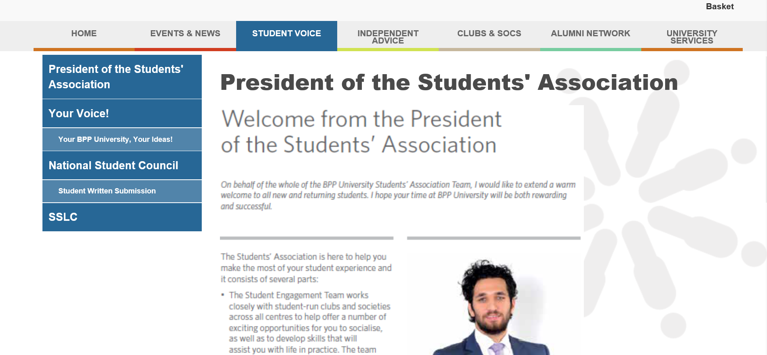

6.2 Going Green
Students want to see more green initiatives within the university environment. Students feel that BPP University should aim to ensure that
all paper is supplied from sustainable sources and/or is produced from recycled material, using chlorine-free bleach whenever practically possible.

Recommendation: Students know that there are recycling bins available in various centres but feel that we should have prominent recycling bins everywhere. There should never be a reason to throw a recyclable can in general waste – however recyclable can bins are difficult to find. A review of how other universities have bright bins for paper, cans, plastic and food should be conducted as BPP University could do more in this area and in the long term it will save money and the environment.

Recyclable cups should be offered where possible and this is a project in which students would love to be involved.

6.3 University Signage
Recommendation: Lack of signage at some BPP centres including Waterloo, London City, and Holborn. Students feel that signage promotes awareness of our institution with improved branding. This need not be expensive, however students feel that tens of thousands of people pass BPP centres daily and don’t notice the small sign, whereas King’s College has giant nine-foot lettering just across the road from the Waterloo centre for example – and BPP should do more in this area. This has been raised in the previous Student Written Submission and students again ask for this to be reviewed – perhaps comparing the photo on the right of this page with the image below. Large window stickers or flag poles would be suitable.

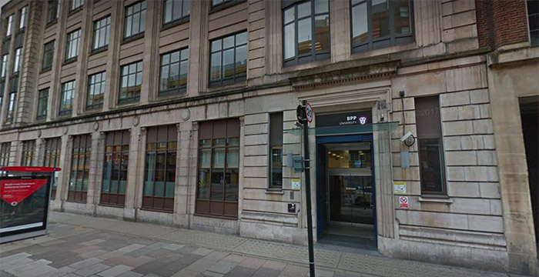

6.4 Staff signatures and out-of-offices
Recommendation: Students feel that that there should be consistent out-of-office replies in staff/tutor/department signatures where possible (this is not always possible), named contacts always given when staff are unavailable, SLA’s of response times from departments and staff and consistency in any photos that they display if any. Some students heard last year that a project was underway to implement this, however are not sure whether this is happening.

Chapter 7 – Thematic Element – Mental Health

7.1 Mental Health
Students at BPP University and across all universities feel that Mental Health is becoming more and more important and Mental Health issues are becoming even more common amongst students. The students want BPP University to lead the way in supporting and improving the mental health of students.
The students would like to commend the University as this year they gave the students a lot of support, which is greatly needed.
In support of World Mental Health Day on Wednesday 10th October, the University worked in partnership with the Students’ Association and held a number of Mental Health stalls and ‘Tea and Talk’ stalls over various locations, these included London Waterloo, Manchester and Birmingham and reached hundreds of students at each of these centres.
Students were able to get free leaflets, dedicated advice, Mental Health nurses from BPP School of Nursing were available and students were able to confidentially speak about wellbeing, health, personal issues and also about sleep disorders.
Further stalls continue to be held across all centres.

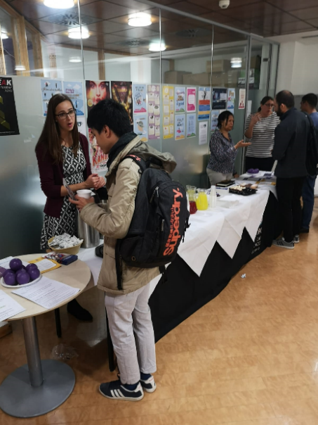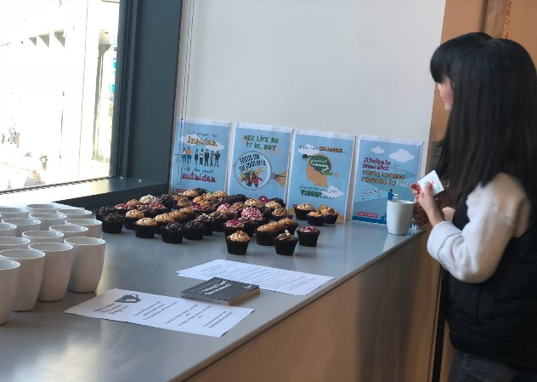

Some students are not aware of the counselling services available and feel that this could be better advertised where possible although this is not always possible.
Some students stated that their tutors should be informed if they have an issue so they can monitor the student and provide support if necessary – however due to confidentially this is not always possible – perhaps if this is explained more prominently to students and also details of counselling services may be more prominently advertised when a student has a bereavement or other issue.
Overall, the consensus is that students are aware of the excellent services on offer and wish to appreciate the excellent work of the Learning Support and Inclusion teams and other teams working in supporting student mental health and student community feel.
Students also appreciate that there is a Crisis Fund which is provided by the University and managed independently by the Students’ Association.

7.2 Mental Health First Aid Awareness Course

Good Practice: As mental health is becoming a growing concern, as part of a campaign to raise awareness of mental health, Student Voice Representatives are offered the opportunity to undertake a certificated and accredited Mental Health First Aid course by the Mental Health Foundation. BPP University pay for this course and 16 Student Voice Representatives have signed up for this training to be delivered in late November 2018. Students wish to thank Nicholas Glossop and Shahban Aziz for offering this excellent opportunity where BPP is leading the sector in such an offering.

“This Mental Health Awareness Training raises awareness of ill-mental health (particularly stress, depression and anxiety), provides tools and guidance for daily wellbeing-management, and aims to remove the stigma surrounding mental health.”

Chapter 8 – Learning Opportunities

8.1 Feedback Turnaround times
Since the last Student Written Submission was written there have many developments on the feedback areas that were outlined.
Students across different programmes note consistency in turnaround times and are appreciative of the projects that are ongoing in this regard. Students feel that they should receive an updated document with details of the agreed turnaround times for all formative and summative work so that they can manage expectations.

8.2 Student Led Staff Excellence Awards
The Students’ Association recently launched a range of Student Led Excellence Awards where students from across all BPP programmes and centres nominated BPP staff that had a significant positive impact on their student experience. These awards serve as a unique opportunity for students to recognise the exceptional contribution of teaching and professional services staff to their education at BPP, and to highlight the kinds of teaching and support that they value and would like to see more of.

Good Practice: Students appreciate the opportunity to recognise, reward and promote excellence amongst all staff (both teaching and non-teaching staff) and over 800 staff were nominated within the first Student Experience Survey and 500 nominations were received in the second. The winners are decided by the Students’ Association and awards and certificates are given at graduation by the Deputy-Vice Chancellor, Professor Sally-Ann Burnett.
One of the hundreds of nominations is as follows – we have pasted it verbatim in this document:

“xxx the criminal law lecturer, without whom, I feel I may not of quite picked up the tone, on how to conduct law assignments exams at the level expected. in fact, I really believe everyone mutually benefited from this lecturer’s ability to simplify information. I think her talent is she really engages with the class and ensures, everyone understands before moving on, she makes clear the structure by which to follow, beyond the simple context of IRAC.
In fact the general consensus between fellow students was how natural she was at teaching, the fact remains proven, in consideration to how well her class did in criminal, when compared to other subjects. Me personally, I am dyslexic, dyspraxic, and have attention deficit disorder. Upon learning of my disability, xxx offered me some of her time and asked if I required any further support from her, which was really a welcomed pleasant surprise, so I asked her to go through a question with me, and it was something about that one to one experience that I understood and retained what was required, in fact in all honest truth it was because of the structure I had learned from her I was able to apply it to other subjects, which I hadn't looked at too well, but managed to get good marks, I found from what I had learned from her, the only thing I needed to do with the other subjects was simply memorise the cases, and I am pleased with the marks I received, I lack retention skills, but strangely, she was able to help me form the link between the structure and applying case law, that I successfully remembered.
I believe, on my own I had no chance, of getting through the first year, because I digest information very different to others, I lose attention fast, but that one meeting with her helped put the whole course into perspective. On final note, I was pleased with all the lecturers, but I know from experience xxx was an exceptional teacher.”

Overall, students feel that BPP University has a clear vision as a leader in quality Higher Education provision with excellent teaching and professional support services. This document highlights numerous areas of Good Practice and some key recommendations which we look forward to being responded to and implemented.

This document is not intended as a comprehensive review of all departments or areas, for example the excellent student-led Student Charter was not discussed, however it is a key barometer and audit of key aspects of the student journey. As we receive more feedback from SSLC minutes and the November 2018 Student Experience Survey, we will add to this document, with a part 2 to this Student Written Submission early in 2019, as we feel that it is a live document and it should not be a full year before actions are formally responded to within this document. Therefore, this is intended as the foundation for a more extensive document due early in 2019.

